Undergraduate Student Loan
To Do List Guidance

Check your To Do List in My Akron’s Student Center to see which item(s) are outstanding.
These requirements can be completed at www.studentaid.gov by selecting the “In School” Tab. Please note; when logging in to complete these requirements please use your student FSA ID. (Don’t use your parents FSA ID).
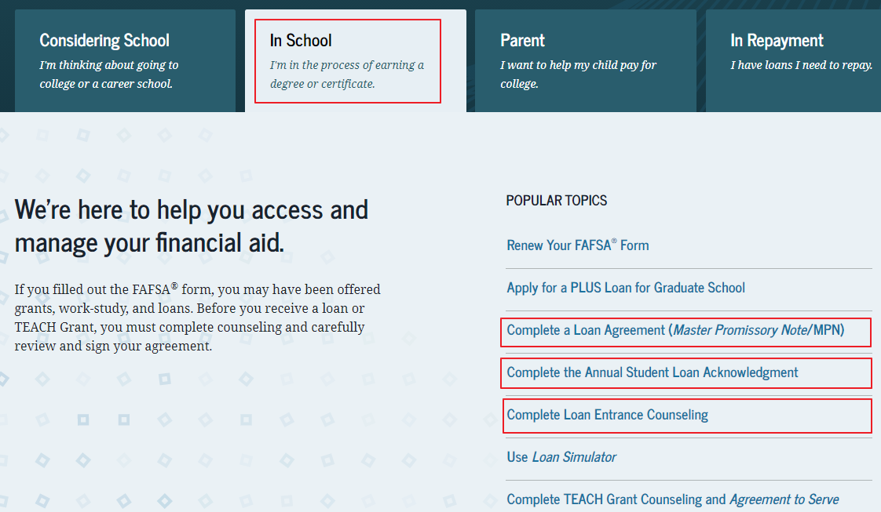
If Entrance Counseling is needed:
- Click on Complete Entrance Counseling and Log in with YOUR FSA ID and Password. and complete the Entrance Counseling process.
If Annual Student Loan Acknowledgement is needed:
- Click on Complete Annual Student Loan Acknowledgement and Log in with YOUR FSA ID and Password. Complete the Annual Student Loan Acknowledgement. This is requirement must be completed each year effective with the 2021-2022 aid year.
If a Master Promissory Note (MPN) is needed:
- Click on Complete A Master Promissory Note (MPN).
- Click on I’m an Undergraduate Student and sign in with your FSA ID and password.
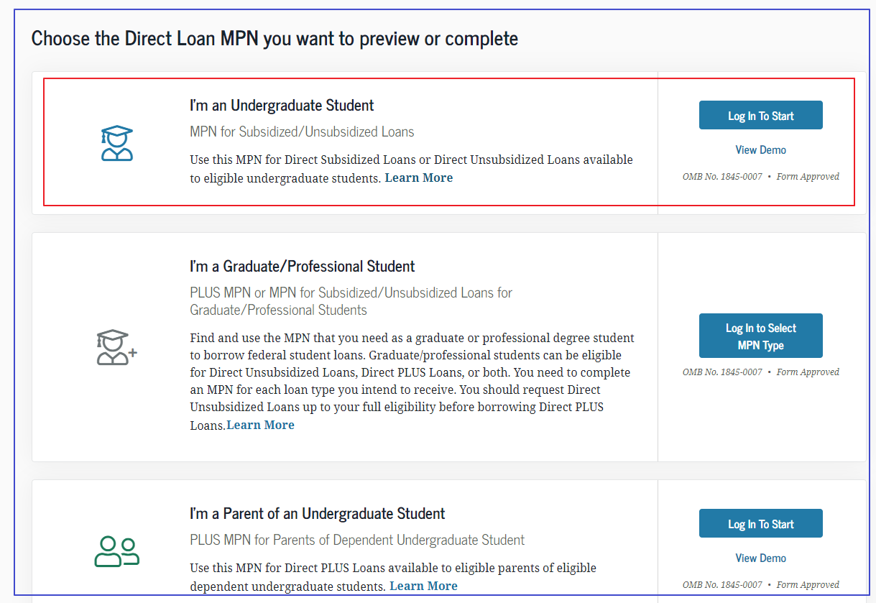
The University of Akron will receive notification when you complete Entrance Counseling, the Annual Student Loan Acknowledgement and/or Master Promissory Note (MPN). Please allow 5 business days for the To Do List to be updated.

